Stragtegic management

**Ali Muhammed Ali Muhammed**

Contents

Executive summary: 3

Brief and overview of the company 4

Implementation: 6

Policies: 9

SWOT: 12

Strengths: 12

Weaknesses: 13

Opportunities – O 13

Threats – T 13

PESTLE: 14

Political factors 14

Economic factors 15

Technological factors 15

Legal factors 15

Environmental factors 16

Porter’s five forces 16

Supplier power - High 17

Customer power - High 17

Competitive rivalry - High 18

Threat of new entry - High 18

Threat of substitution - Low 19

EFE: 22

**Company performance** 23

**Company vision & mission** 23

**Current vision & mission** 23

**Evaluation of the vision and mission** 24

**Proposed vision & mission** 24

**Organization structure** 26

**Corporate governance** 26

**Organization culture** 27

**Corporate resources** 27

RBV model 29

Ife matrix 30

**SWOT Analysis** 32

**BOSTON CONSULTING GROUP MATRIX (BCG)** 33

**IE Matrix** 34

**Quantitative Strategic Planning Matrix (QSPM)** 35

Bibliography 37

References: 37

# Executive summary:

luxury eleganz is operated in cairo owning retail stores under the names fortune and DELSEY PARIS. It owns 30% of the cosmetics industry market share in egypt the company dependa mainly on export luxury beauty products from france and italy that fulfill wants of the high class people and dealing with another retailers to supply them with the mid-clsss products so they can have a large number of consumers. The company system mainly depends on team orientation and producing rare type of products. Also they have monthly KPI analysis to check company prodactivity.

As a result of the economic and social turmoil, due to the Corona crisis and the precautionary decisions, the company is going through an unstable period in terms of the general sales rate, which is because they sell a luxury product that is not necessary for human life, which is no longer a necessity for the buyer at the present time. In addition, the government imposes some difficult laws to make it difficult to import luxury goods and allocate hard currency to import what is more important, such as the requirements of the Ministry of Health, despite the approval of the World Health Organization on the validity of the products.

The company has strong competition with a company with Mazaya and Wogoh in all aspects, which is what puts pressure on the company. This makes even the agreement with suppliers difficult because of their hard requirements to give trademark rights to retailers on the otherhand the products they pre can be easily replaced or dispensed with, which poses a great danger. The company main strengths laying on having right of large number of luxury, rare brands in egypt like PUBA while thier main weakness no having atrong IT systems to make an easy connection between departments and stores.

The company aiming to apply some changes in order to develop their brand name and increase the sales and profit share.

# Brief and overview of the company

Fortune stores were operated in Egypt in 1997 to be one of the first beauty products retailers in Egypt. According to Unitrade company profile, on 2021 Egypt luxury decided to invest in retail business in Egypt by owning Fortune retail brand and DELSEY PARIS. Fortune has 8 branches around Egypt located in Cairo, Alexandria, Mansoura and Hurghada. And 8 branches under the brand DELSEY PARIS. the company head office operates in new Cairo, employing more than 400 employees distributed among the retail branches, stores, and head office. Over 20 brands are included in the brand portfolio like GIVENCHY, PUPA and CLARINS. As it considered as pioneer in the field of importing luxury perfumes, cosmetics, and accessories that address high class of people. The company main competitors in Egypt are MAZAYA and WGOGH as they are strong competitors with strong brand names operating around Egypt with high number of retail branches.

# Implementation:

|  |  |  |  |  |
| --- | --- | --- | --- | --- |
| Tasks | Who will perform the task? | When to perform the task? | How will the task be performed? | Resource Needed |
| 1) Prepare new international business plan | Marketing & finance departments | By May 25, 2021 | -Determine the mission of the firm.  -Conduct accurate and up-to-date research.  -Keep the financial records of the firm up to date. | -Highly qualified personnel.  -A management staff that is creative.  Money.-  Reliable distributors.-  -Appropriate locations. |
| 2) Conduct a foreign market research & identify international markets | Marketing department and department of commerce | May 21, 2022 | -Conduct surveys.  -Interviews in depth.  -Teleconference through video.  -Examine the data collected from customers. | -A marketing staff with a creative flair  Finances-  -Campaign concepts that are unique  good research strategy- |
| 3) Evaluate & select methods of distributing products abroad | Marketing department | November 23, 2022 | -Look for vendors and investors who are credible.  -Collaborate with dependable distributors.  -Subsidiaries are a type of third-party company.  -companies that are subsidiaries of a parent corporation.  -Work along with the agents.  -Representatives who are effective. | -A list of hypermarkets where the items will be sold.  More money.-  -A bustling neighborhood in which to construct the stores.  -Employees who can be trusted. |
| 4) Set Reasonable prices and navigate the legal barriers of exporting | Finance & | Jan 1,2022 | -Collaborate with financial divisions to determine appropriate pricing.  -Research the prices of competitors in the same business.  -Gather information about legal morass of exporting.  -Asses competitor’s prices. | -Managers from the host  country.  Funds -  -Innovative marketing team. |
| 5) Conduct a deep market research | Research & development department | April 27, 2022 | -Obtain extra information on target clientele to improve decision-making.  -Conduct polls  -Have a videoconference -Analyze the data gathered | online polls.-  -Expert groups.  -Increase the number of computers.  Invest.- |
| 6) Online shopping application | Marketing &IT department | By august 30, 2022 | -Compelling online offers to entice clients.  -Use social media to promote the app-Ask for aid from influencers.  -Promotional codes are codes that are used to increase the value of a product. | Employees that are well-trained and skilled.  Financial assistance.  A commercially creative team. |

# Policies:

**Job Posting Policy:**

The company uses a number of methods to market available vacancies.

The first options to seek are internal job advertisements and referrals.

The second option is to use recruiting agencies, newspaper ads, and publications.

**Selection Policy:**

A committee of HR and line managers conducts a series of interviews to ensure that candidates are picked on a competitive basis, taking into consideration their experience, talents, and appropriateness for the job.

The selected candidates will get an offer letter detailing their start date, remuneration package, and work responsibilities.

**Internal Mobility and Transfer Policy:**

The company emphasizes internal transfers and promotions to replace vacant jobs, although it retains the ability to employ from outside as necessary.

The interviewing process should be followed by both internal and external applicants.

**Conflict of Interest Policy:**

No first-degree relative should work in the same department or management line to prevent a conflict of interest.

**Work Contract Policy**

The company's hiring policy complies with Egyptian Labor Law No. 12/2003

It is based on the idea of a labor contract between the employer and the employee for a set length of time.

A contract that expires by the end of the specified time can be renewed; for a period or more, through an explicit agreement between both sides.

|  |  |  |  |  |
| --- | --- | --- | --- | --- |
| Tasks | Who will perform the task? | When to perform the task? | How will the task be performed? |  |
| 1) Prepare new international business plan | Marketing & finance departments | By May 25, 2021 | -Determine the company's mission.  -Conduct current and accurate research.  -Keep the company's financial records up to date. |  |
| 2) Conduct a foreign market research & identify international markets | Marketing department and department of commerce | May 21, 2022 | -Do surveys  -Interviews  -Video conferencing  -Analyze customer data |  |
| 3) Evaluate & select methods of distributing products abroad | Marketing department | November 23, 2022 | -Look for reputable vendors and investors.  -Work with reputable distributors.  -Subsidiaries are third-party companies that are owned by a parent company.  Collaborate with agents-  Effective representatives. |  |
| 4) Set Reasonable prices and navigate the legal barriers of exporting | Finance & | Jan 1,2022 | -Collaborate with financial divisions to determine appropriate pricing.  -Research the prices of competitors in the same business.  -Gather information about the legal quagmire of exporting.  -Examine the prices of competitors. |  |
| 5) Conduct a deep market research | Research & development department | April 27, 2022 | To aid in decision-  making, get additional information about target clients.  -Conduct polls  Hold a videoconference  -Assess the information obtained. |  |
| 6) Online shopping application | Marketing &IT department | By august 30, 2022 | -Attractive online deals to entice customers.  -Promote the application on the internet. |  |

**External Environment**

# SWOT:

## Strengths:

**Effective marketing and promotion advertising-**

-Strong R&D capabilities

-Quality assurance

Increasing the rate of production-

Positive customer interactions-

National and international brand awareness-

-Experienced and qualified management

Reliable channels of distribution**-**

## Weaknesses:

**Dealing with financial dangers-**

-A drop in the cash flow ratio

-Employee turnover is a problem

Inventory management-

-Taxes are expensive

-Employees' happiness

## Opportunities – O

**Factors affecting import and export-**

Low-priced items are on the rise-

Relationships with Arab nations in terms of health-

Rapid technological advancement.**-**

## Threats – T

**The rate of inflation.**

Some foreign countries, such as Turkey, have strained relations with the United States.

Imported cookers with cutting-edge technology.

Market competition is fierce.

# PESTLE:

Any company must be making a conscious decision to go global and achieve the highest profits, and to implement that ambition, fortune must organize its own PESTLE. *PESTEL is a strategic planning tool to scan the context of the campaign. It examines political, economic, social, technological, environmental and legal external factors likely to have a bearing on the campaign (Center, 2012).

## Political factors

Political factors measure the extent of government interference in the economy and business policy of a company. In order to apply these factors to LUXURY since the raw materials or products that the company imports from abroad (such as France) are all cosmetics and perfumes, so these imports are considered provocative goods by the government. The government imposes taxes on imports, and the company has to pay taxes to be able to import any commodity because the country has a certain percentage of hard currency, so it wants to direct this percentage to vital imports such as food resources. The state imposes daily conditions and taxes that make it difficult for them to import from abroad, and this results in reducing the proportion of provocative goods. Certainly, these terms and conditions negatively affect the company and its profits, but the company is obligated to pay all taxes to supplement its own business.

## Economic factors

LUXURY was affected more than once by economic factors, as the Covid-19 pandemic affected Egypt’s economy and business, the economy was deteriorating and the income ratio decreased, and the decision of home isolation and quarantine was implemented, as it negatively affected LUXURY a great deal because the company sells high-priced products in addition to The products they provide are not essential, especially during the pandemic period, because people were only interested in food and health so that they could pass this period without harm. In 2016, the state’s economy was affected by the sudden flotation of the pound, as the company was forced to import products at prices more than the usual ones, in addition to the decrease in the percentage of people to buy their products and dismiss them due to their high cost.

## Technological factors

Technology has an important role in managing any business in Egypt. LUXURY not at all involved in the new technology world, and this reflects the lack of overlap and communication of all the company's system, as the divisions are difficult to fit in and overlap, as the company relies heavily on hard copies. The company must rely more on technology in order to facilitate a lot for them in their work affairs, because not using it sufficiently affects them negatively.

## Legal factors

The health conditions issued by the health authority in Egypt, which checks all products imported from abroad to ensure their safety, but on the other hand the health organization devise ways to prove that the products are not healthy for an indefinite reason in order to reduce the percentage imported from abroad. These exaggerated health conditions negatively affect Fortune.

## Environmental factors

LUXURY relies heavily on seasonal work, as it sets the prices of products according to the season, for example, the Ramadan season, which negatively affects sales in a large percentage because Egypt is a Muslim country, so women do not use in this holy month the products that the company sells, such as cosmetics, and that Out of respect for the month and fasting, the company lowers the prices to motivate women to buy the products and use them at a later time. For another example, it positively affects the company's sales, the festive season, Sham El-Nessim, etc.

# Diagram Description automatically generatedPorter’s five forces

and which drive the way economic value is divided among industry actors (ISC, 2008).

## Supplier power - High

Suppliers have the right to choose which organization distributes their products to them. When LUXURY offers to suppliers (product owners) to distribute their own products, the supplier imposes certain conditions in order to take the required quantities from them. The supplier asks the company about the locations of the shops, how many places will distribute the special products to them, how the company's structure is organized, how many trucks transport the goods and how many warehouses. The company is facing difficulty in agreeing with suppliers because the locations of the shops are not excellent, in addition to the company's lack of ownership of transport trucks, but rather they rely on renting shipments. Moreover, Fortune Company suffers with their suppliers because they have such a principle that does not change, such as “pay before receiving” and thus the opposite of the principle of the Company “see the product before payment”.

## Customer power - High

The strength of the customer was greatly affected after the revolution of January 25, 2011, as the percentage of income in Egypt was higher before the revolution, and Fortune issued its sales on the medium and high degree. After the revolution, the economy deteriorated and the income ratio of the citizen (consumer) declined, the middle class disappeared, and wealth became completely dependent on the upper class. Also, after the floatation of the Egyptian pound in 2016, the percentage of income decreased significantly, affecting everyone. The company strives to maintain its current customers and build a larger audience. The power of casters is considering high.

## Competitive rivalry - High

LUXURY retail stores such as Fortune faces a major competitive threat in the field of makeup and cosmetics, where Fortune competes with giants such as mazaya and wogoh, where the brand share is about 30%, and it is considered a small percentage for the market share of both mazaya and wogoh. Fortune is located in places to display the product less than any other competitor. Moreover, the places where their store is located is less marketable than the stores of the competing companies (such as better places in malls). There is also another obstacle that reduces their position in the market is that Fortune does not have agencies for all suppliers, and this is considered a defect for customers and they will go directly to competitors who have agencies for all brands. The company also hinders the movement of transportation, as they depend on renting trucks responsible for shipping, and on the other hand, some competitors own these trucks such as Mazaya. Therefore, the competitive rivalry of Fortune is very high.

## Threat of new entry - High

Any new entry into the market would constitute a major threat to LUXURY. Looking at the company's profits and market share, it is clear that any new entry will take a percentage that is not a small and almost a lot of the profits achieved by Fortune because the percentage is not enough to prevent the threat of any new entry, so the profitability will decrease to a competitive rate.

## Threat of substitution - Low

The availability of few alternative products to the products offered by the company due to the wide market in which the company trades. The company does a lot of special offers and promotes its merchandise in stores so that the customer has all the options in the field of cosmetics, and this results in the threat of alternatives is low.

In Conclusion, it is considered a semi-attractive business as opportunities include high bargaining power for both suppliers and buyers as well as low threats of substitutes and high threats from both new entry and competitive competition.

|  |  |  |  |  |
| --- | --- | --- | --- | --- |
| **Tasks** | **Have measure changes occurred in firm`s internal strategic position?** | **Have measure changes occurred in firm`s External strategic position?** | **Has the firm processed satisfactorily towards achieving its objectives?** | **Results** |
| **Task1** | Yes | No | Yes | Corrective action |
| **Task2** | Yes | Yes | Yes | Corrective action |
| **Task3** | Yes | No | Yes | Corrective action |
| **Task4** | Yes | Yes | No | Corrective action |
| **Task5** | Yes | Yes | Yes | Corrective action |
| **Task6** | Yes | No | No | Corrective action |

|  |  |  |  |  |
| --- | --- | --- | --- | --- |
| No | **External** | **Weight** | **Rating** | **score** |
|  | **OPPORTUNITY** |  |  |  |
| 1 | Acquisition of global brands | 0.07 | 4 | 0.28 |
| 2 | A brand with loyal customers | 0.06 | 4 | 0.24 |
| 3 | Average number of branches | 0.05 | 4 | 0.2 |
| 4 | High quality products | 0.05 | 3 | 0.15 |
| 5 | Very healthy products | 0.05 | 4 | 0.2 |
| 6 | High number of females in Egypt (Almost twice as many men) | 0.07 | 3 | 0.21 |
| 7 | Implement online shopping | 0.06 | 4 | 0.24 |
| 8 | Product mix expansion | 0.04 | 3 | 0.12 |
| 9 | Social influences and makeup artist trend | 0.07 | 4 | 0.28 |
| 10 | Growth of cosmetic market | 0.08 | 3 | 0.24 |
|  | **THREATS** |  |  |  |
| 1 | High product prices | 0.05 | 3 | 0.15 |
| 2 | Offer non-essential products | 0.04 | 3 | 0.12 |
| 3 | The disappearance of the middle class | 0.07 | 4 | 0.28 |
| 4 | arbitrary government requirements | 0.03 | 3 | 0.09 |
| 6 | current panademic conditions | 0.04 | 4 | 0.16 |
| 7 | Poor store design | 0.02 | 4 | 0.08 |
| 8 | The weak dependence on the Internet in the business despite the development of the world and its tendency to electronic work | 0.02 | 4 | 0.08 |
| 9 | The rise in the price of the dollar | 0.04 | 3 | 0.12 |
| 10 | Very high supplier’s power | 0.06 | 3 | 0.18 |
| total |  | 1 |  |  |

# EFE:

**Current situation**

## **Company performance**

LUXURLAY current performance is considered as mid-performance due to the current situation around the world. The company performance is tested through P&L every 3/6 months by monitoring how company works and analyze if any part need any adjustments such as price list, which may be adjusted every 3 months depends on the price the company import the products with. After analyzing the company progress, the P&L contains evaluating the employees monthly by check their portfolios every 6 months and evaluate their work which help in dividing work and setting the action plan. Moving to the last phase which is monitoring the sales and market weight which also helps in setting the plan to decide which products should be imported and which should not. According to Hany Shawky the admin manger LUXURLAY market share is about 30%.

## **Company vision & mission**

### **Current vision & mission**

According to (fortune ) “ their mission is to deliver the best possible services with our well-trained Beauty Advisors to our valuable customers” while their vision “offer a variety of options to meet your needs” (fortune )

### **Evaluation of the vision and mission**

The mission is understandable, short but brief focusing on only one goal. It may should reflect to all company goals. So it should be broader. The vision statement is very week, should be contain more details about the company future goals. Very short and not brief enough.

### **Proposed vision & mission**

According to the new company profile, the company proposed vision is “strive to be the leading name in the Egyptian beauty market by listening to their customer needs and continuously refining and improving their individual and company capabilities”. (Uni-trade, 2021) on the other hand their mission is “aiming to build on the very long history of Uni-trade in Egyptian Market and develop both Distribution and Retail sectors using our expertise up to the international standard” (Uni-trade, 2021).

**Company polices**

According to the company staff member manual report

* 1. job posting policy which is about using two different channels to advertise the vacant positions.
  2. selection policy process consists of a series of interviews done by a committee from the HR and the line managers; to ensure that selection is done on a competitive basis and has considered experience, competencies, and adequacy to the job.
  3. Internal mobility and transfer policy

gives priority to transferring and promoting from within to fill vacant jobs; however it reserves the right to recruit externally when necessary

* 1. conflict of interest policy

No first degree relative should be working in the same department or management line to avoid conflict of interest

Also there are the employment policy, wages and salary policy, training and development policy standards of conduct policy and safety policy.

**Internal audit**

## **Organization structure**

### **Corporate governance**

#### **board of directors**

the board of directors contains three members, Padma Kumar is the head of the board while Mohsen taha and Kashif Shehzad are members of the board. Mohsen taha is the responsible manager of LUXURAY retail stores in Egypt such as Fortune and DELSEY PARIS.

#### **top management & chain of command**

There are sperate mangers for each department as shown in the figure, finance manager, training manger, sales manager… (etc)The company is decentralized management, all mangers work together in order to take decision not only the head managers. For example, no individual supervisor or manager has the authority to change policies at any time. The top management is highly involved in the strategic management as they are responsible to discuss with the mangers their decisions.

## **Organization culture**

LUXURAY company has some values which formed the company culture. First, the company highly encourage team working and open minded, as they are open to new ideas and changes, using creativity and all workers feel confident to suggest new ways of doing things, find solutions and adjust rapidly to new challenges. On the other hands all employees should shows an understanding that others may have a different view or position for things, so they have to respect the other opinions. another important element is equality. The company provide fair and equal opportunities for all people. the employees Strive to achieve the highest quality, effectiveness and dignity in both the process and products of professional work. the company focusing on luxury brands not aiming to take any risks.

## **Corporate resources**

The company imports all their products from abroad such as Italy and France in order to get the highest quality. The brands the company deals with are rare brands in Egypt such as PUBA, Euro Italia, Tiziana Terenzi and Lalique Beauty. These brands offer high priced products but with very high quality. Its easy to substitutable them with lower price products but not at the same level of quality. LUXURAY has the ownership of more than 20 rare brands which is high advantage for the company.

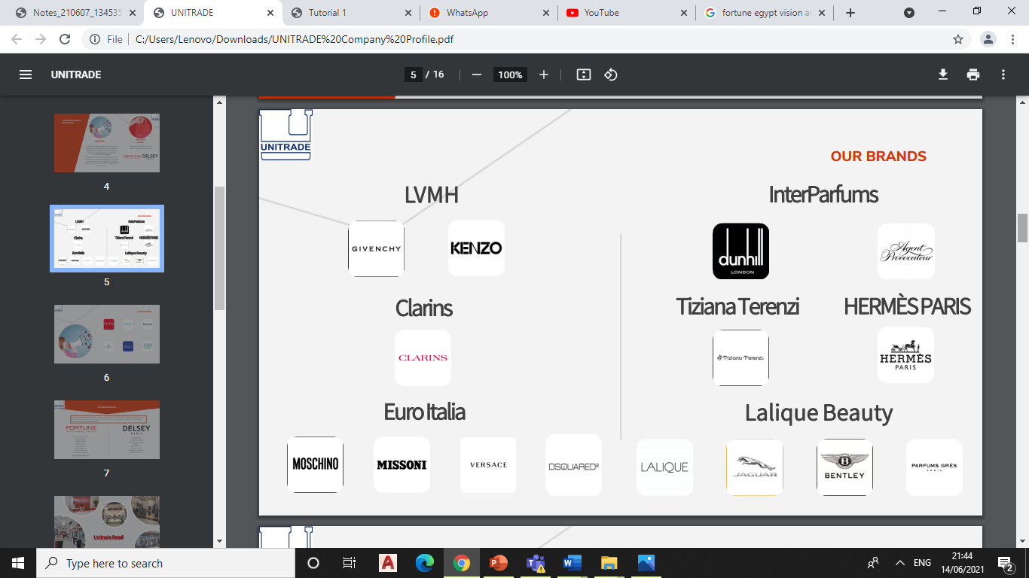

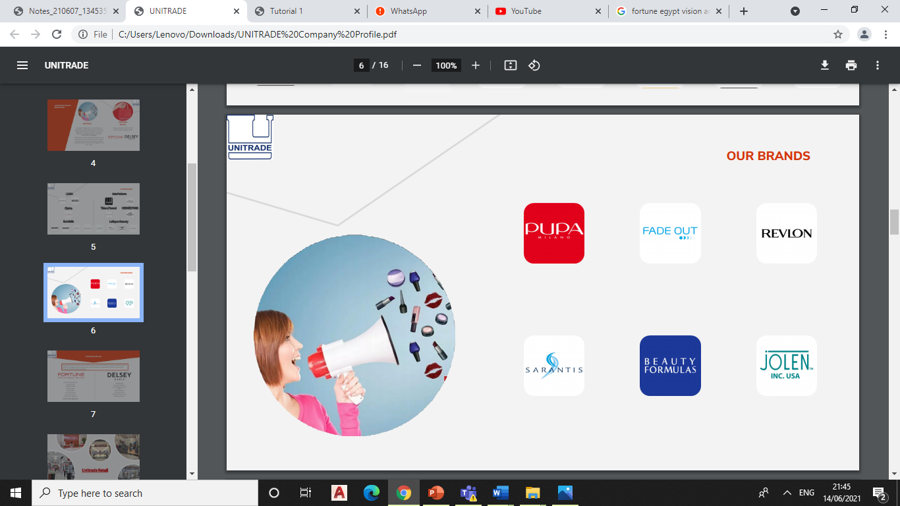

### RBV model

**Valuable**

**yes**

**Temporary competitive advantage**

**Rare**

**yes**

**Costly to imitate**

**And is the firm**

no

**Organized to capture value?**

the products are valuable as they are unique in beauty industry in Egypt. So, the will help the company to increase value offered to consumers. Those high-quality products are rare in Egypt only acquired by those luxury brands which most of their rights owned by the company

Those brands offer very high-quality products, its costly to create similar products with the same quality so they are hard to imitate.

The company isn’t organized yet to capture the value as, their store locations are not organized yet as they have poor IT system, undistinguished store locations and they don’t have dedicated transport vehicles. So, the company have unused competitive advantage.

## Ife matrix

|  |  |  |  |
| --- | --- | --- | --- |
| Internal strengths | weight | rating | Weighted score |
| 1. monopoly international brands | 0.06 | 3 | 0.18 |
| 1. high team working | 0.06 | 3 | 0.18 |
| 1. effective company culture | 0.05 | 2 | 0.1 |
| 1. loyal employments | 0.05 | 2 | 0.01 |
| 1. good reputation and image | 0.06 | 3 | 0.18 |
| Internal weaknesses |  |  |  |
| 1. Poor IT system | 0.07 | 3 | 0.21 |
| 1. Poor internet marketing | 0.08 | 3 | 0.24 |
| 1. Hard copy saving system | 0.05 | 2 | 0.1 |
| 1. Price competition | 0.07 | 2 | 0.14 |
| Total weighted score | 1 |  | 1.33 |

-Monopoly got high rate because it’s the main company advantage

- team working is the most important element of the company’s culture, so it got high rate

- effective company culture and loyal employments both got mid-rate as they are not the main strengths, but they are important to

- the good reputation is very important in field of beauty in order to trust it safety, so it got high rate

Moving to weaknesses

* The poor IT system is a big obstacle facing the company as it may causes a big loss due to the poor connection between departments, stores or retail stores. So, it got high rate
* Now days the E-marketing is the marketing leader, so having a poor E-marketing is a real weakness so it got high rate too
* Hard copy system is not that bad it sometimes be useful so it got mid-rate, but it should be just a support for a strong IT system
* Price competition got mid-rate because the products the company offers are rare and it may be overpriced but it has their loyal consumers, so it got mid-rate.
* As the total weighted rate is 1.33 which lower than the average rate (2.5), the company is weak against its competitors.

# **SWOT Analysis**

Every company has analysis to everything SWOT analysis shows us the strength, weakness, opportunities, and threats for Fortune company this will be covered

1. Strength: if they need makeup from a high end brands they don’t have to import anything they will just simply get the products they want from the brand itself, also they can resell them to other stores either way they are making revenue, example: Givenchy
2. Weakness: the company doesn’t have strong IT system this is a very serious problem because the IT system include everything about the company and there history and future plans, also they record everything as a hard copy all of their data are in hard copy which is very difficult to deal with.
3. Opportunities: opening outlets in new places with lower rent cost this opportunity will make a huge difference and will benefit the company a lot by doing this step.
4. Threats: due to the global pandemic (COVID-19) there were some hard choices to make and the result from these choices affected the company very badly, example: lockdown during the pandemic. Increasing of the dollar price also would affect there future plans because if the dollar price increases every thing will cost them more and they will be forced to increase there prices in order to keep up with there cost and make revenue at the same time.

The appropriate strategy for Fortune company is “ST” (strengths, threats) this will help fortune company to reduce the threats with the opportunities available.

# **BOSTON CONSULTING GROUP MATRIX (BCG)**

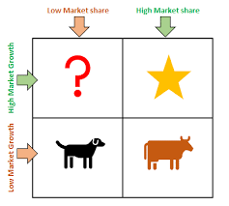In this strategy it is divided into four sections first is low product to remove which is describing the rate of how many products they need to remove because they are not making profit from them anymore, second products need investment is the rate of the product that they need to invest in more in order to make more profit, third star product which is the products that are always making profit and need to be available all the time, finally cash cow products are the products that need to be existed in order to increase the revenue from the better products.

1. Low Product to Remove: “Low” which means the rate of this category is low because they don’t have products that doesn’t make revenue, so they don’t need to remove any.
2. Products Need Investment: “High” this means that Fortune company invest in new products and brands in order to attract more customers.
3. Star Product: “High” this means they have a star product which is always needs to be available because the demand is high on these products and this called fast moving products, example: lipsticks, Lip gloss.
4. Cash Cow Products: “Low” which means the rate of this category is low but also important because they need to increase the revenue of the other products, example: buying other lipsticks the demand of them are low in order to show that the other lipsticks are worth the money, so when a customer compare the two of them they will see that the other product is much better and eventually buy it.

In conclusion Fortune company do not have products to remove because almost of their products are sold at a good ratio, also the cash cow products are low because they do not use this method to increase their sales, the products need investment are high because they invest constantly in new products and brands to keep up to date and what customers need, finally the star product are at a high rate and called fast moving products which means they are sold quickly and constantly and needs to be always available for the customers due to the high demand on these products.

# **IE Matrix**

Fortune Company External factor evaluation is 2.64, while the internal factor evaluation is 2.63. this locate Fortune company within V quadrant, which means that Fortune company should be focusing on holding and maintaining the business.

Market Development:

1. Open new outlets
2. Change the store design and the store atmosphere
3. Change the identity in order to attract customers

Product Development:

1. Dealing with more brands in order to increase their revenue and products

# **Quantitative Strategic Planning Matrix (QSPM)**

QSPM is a high-level strategic-management technique that examines potential options and compares feasible-alternative-actions. The implementation of the QSPM matrix, whose analysis is included in the report's appendix, was based on the examination of each of the internal and external components stated in the internal factor evaluation matrix and the external factor evaluation matrix. The comparison was based on the two tactics that the previous matrices had proposed, which is the product development strategy as well as the market development strategy. However, the QSPM matrix analysis resulted in a higher score for the market development plan. In other words, Fortune will be commended for focusing on the development of a variety of items that may be launched under the company's brand in order to increase the company's market share and existence. According to QSPM's total-attractiveness-score, EFE, and IFE, the market-development-strategy scored higher than the other alternative-strategies. As a result, market-development-strategy is recommended for Fortune.

Market Development: introduce an existed product in new markets

Market Penetration: selling an existed product in the same markets in order to gain more market shares

Product Development: introducing a new product of the company to the consumers

Related Diversification: adding a new product line

# Bibliography

(n.d.). Retrieved from fortune : https://fortune-egypt.com/

Uni-trade. (2021).

# References:

Center, V. K. (2012, January 3). Retrieved from Virtual Knowledge Center: https://www.endvawnow.org/en/articles/1182-pestel-analysis.html

ISC. (2008). *INSTITUTE FOR STRATEGY & COMPETITIVENESS*. Retrieved from The Five Forces: https://www.isc.hbs.edu/strategy/business-strategy/Pages/the-five-forces.aspx